Brandon Dooley

Dooleyb1@tcd.ie

Date of Experiment: 16/12/2016

Lab Session: 14:00-16:00

*All circuit diagrams created using CircutDiagram*

*© 2016 Circuit Diagram*

Brandon Dooley ( #16327446 )

CS1025 Laboratory Experiment 5

CS1025 Laboratory Experiment 5

# Objective

* To use a 2N7000 E-MOSFET to create an inverter (NOT Gate).
* To prove the truth table for a NOT Gate using a 2N7000 E-MOSFET.
* To determine the gate that comes as a result of two E-MOSFET’s in series.

# Method (Part One)

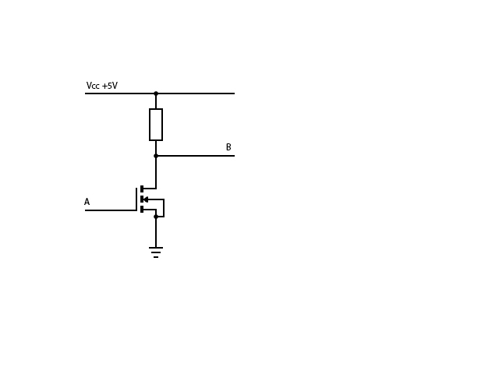 ***Fig 1.1***

1. The apparatus was set up as shown in *Fig 1.1*, with a 1kΩ resistor connected in series to the *drain* of a 2N7000 E-MOSFET. The VCC was also connected to an LED at B used to detect current flow. An external source was connected at A which is the *gate source voltage* (VGS). The *source* of the transistor was then connected to ground. By using a switch VGS was varied between 0V and +5V. The voltage across B was measured at both stages and the state of the LED was also recorded. The results were plotted in the form of a truth table.

# Results (Part One)

|  |  |
| --- | --- |
| A (V) | B (V) |
| 0 | 5 |
| 5 | 0 |

# Analysis (Part One)

* When the voltage at A is set to 5V using a switch, the corresponding voltage at B can be read to be 0V using a voltmeter. This is also confirmed by the state of the LED as it is emitting no light.
* However, when the voltage at A is changed to 0V using a switch, the voltage at B now becomes 5V. This is once again confirmed as the LED is now emitting light.
* When the voltage at A (VGS) is set to 0V, it is below what is known as the *gate source threshold voltage*. As a result it is not large enough to sufficiently break down the depletion region to allow current to flow between the drain and source. As a result the current as a result of VCC  cannot flow through the transistor and takes the quickest route to ground, i.e through the LED at B, causing it to emit light.
* However, when the voltage at A (VGS) is changed to +5V, it is now above the *gate source threshold voltage*. It is now large enough to break down the depletion region between the drain and source and to allow current to flow. As a result of this the transistor is now able to conduct current and thus the current as a result of VCC travels through the drain and down to the source. This can be seen since the voltage at B was measured to be 0V and the LED is now not lighting anymore.

# Uncertainty & Error (Part One)

* Power lost through other energy conversions e.g heat
* Internal resistance of devices e.g the multimeter impacting readings
* Human errors when taking voltage readings off the multimeter

# Conclusions(Part One)

* The circuit as seen in *Fig 1.1*  can be said to operate as an inverter. When the control voltage at A is HIGH (+5V) the output voltage at B is LOW (0V). On the other hand, when the control voltage at A is LOW (0V) the output voltage at B is HIGH (+5V). The truth table seen above also matches that of a boolean inverter (NOT Gate).

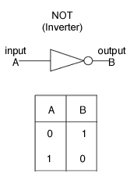

# Method (Part Two)

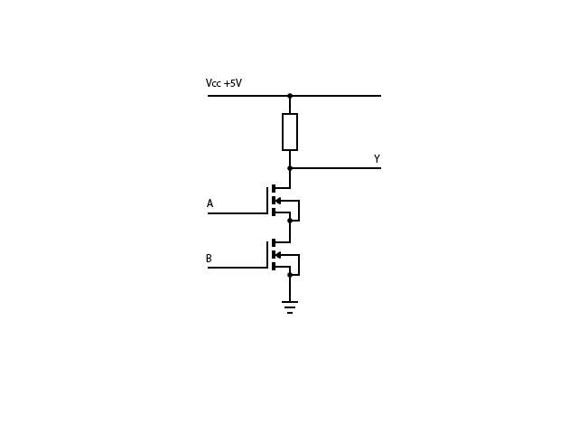 ***Fig 2.1***

1. The circuit was then changed and another 2N7000 E-MOSFET transistor was connected in series as shown with the *source* from the first transistor being connected to the *drain* of the second transistor. The value of the resistor remained at 1K. Similar to part one, the VCC was also connected to an LED at Y which was used to detect current flow. An external source was connected at A and at B which is known as the *gate source voltage* (VGS). The *source* of the second transistor was then connected to ground. By using a switch the voltages at A and at B were varied between 0V and +5V. The corresponding voltage across B was measured at each stage and the state of the LED was also recorded. The results were plotted in the form of a truth table.

# Results (Part Two)

|  |  |  |
| --- | --- | --- |
| A (V) | B (V) | Y(V) |
| 0 | 0 | 5 |
| 0 | 5 | 5 |
| 5 | 0 | 5 |
| 5 | 5 | 0 |

# Analysis (Part Two)

* This time the LED remained emitting light at all test stages besides when the control voltages at A and B were both set to +5V.
* The output voltage at Y was HIGH (+5V) when the input voltages were different or both LOW (0V).
* When the control voltages at A and B are both set to LOW they are both said to be below the VGS threshold voltage for both gates and are thus not significant enough to break down the depletion region between the transistors’ drain and source and allow current to flow. As a result, the current as a result of VCC takes the path of least resistance to ground down through the LED at Y and the LED emits light.
* When one of the control voltages (either A or B) are set to HIGH and the other is set to LOW, only one is above the VGS threshold voltage and is able to break down the depletion region between the transistors drain and source. However, one of them is still below this threshold voltage and as a result current cannot flow through this transistor. Once again the current as a result of VCC  takes the path of least resistance to ground through the LED at Y and the LED again emits light.
* However, when both of the control voltages are set to HIGH both are above the VGS  threshold voltage and as a result are both large enough to break down the depletion region between the drain and source on both transistors. This time the current as a result of VCC  can now travel down through both of the resistors and directly to ground. As a result, the LED doesn’t emit light at this stage and the voltage at Y can be read to be 0V.

# Uncertainty and Error (Part Two)

* Power lost through other energy conversions e.g heat
* Internal resistance of devices e.g the multimeter impacting readings
* Human errors when taking voltage readings off the multimeter

# Conclusions(Part Two)

* It can therefore be concluded that the circuit as seen in *Fig 2.1* acts as a Boolean NAND Gate. All ouput voltages are HIGH besides when the control voltages are both HIGH. The results as seen above directly coincide with that of the truth table of a NAND Gate.

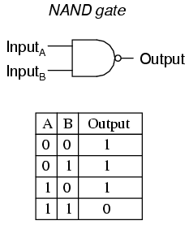

* **Sidenote:** If the resistor value had of been changed from 1kΩ to say 5kΩ, the current as a result of VCC would have been substantially lower as a result of *Ohm’s Law*. For certain transistors if the resistor at the drain is larger than the ‘ON’ resistance of said transistor then the output will be LOW. Thus, neither of the ‘transistor gates’ would have been able to perform their functions if 5kΩ was larger than the ‘ON’ resistance of the transistors.